**Normal**

python colebank_model.py -i paciente-normotensive.xlsx -kt 1.0 -kea 1.0 -krs 1.0 -krp 1.0 -o NORMAL2/

python uq_colebank.py -i paciente-normotensive.xlsx -o UQtest/

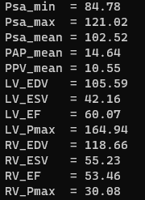

**Hipertenso**

python colebank_model.py -i paciente1.xlsx -kt 1.0 -kea 1.0 -krs 1.0 -krp 1.0 -o HIPERTENSO/

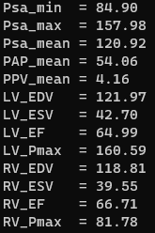

**Covid-19**

python colebank_model.py -i paciente-normotensive.xlsx -kt 0.75 -kea 0.70 -krs 1.0 -krp 2.75 -o COVID/

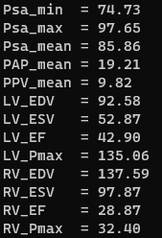

**Hipertenso + Covid-19**

python colebank_model.py -i paciente1.xlsx -kt 0.75 -kea 0.70 -krs 1.0 -krp 2.75 -o HP_COV19/

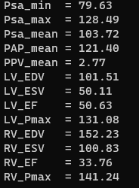

#Gráficos Comparativos

plt.plot(t[k:],Era[k:], color = 'purple', label ='Era')

plt.plot(t[k:],Era_CV[k:], color = 'black', label ='Era_CV')

plt.legend(loc='best')

plt.xlabel('Time [s]')

plt.ylabel('Elastance')

plt.show()

plt.plot(t[k:],Ela[k:], color = 'red', label ='Ela')

plt.plot(t[k:],Ela_CV[k:], color = 'green', label ='Ela_CV')

plt.legend(loc='best')

plt.xlabel('Time [s]')

plt.ylabel('Elastance')

plt.show()

plt.plot(t[k:],psa[k:], color = 'red', label ='Psa')

plt.plot(t[k:],psa_CV[k:], color = 'green', label ='Psa_CV')

plt.legend(loc='best')

plt.xlabel('Time [s]')

plt.ylabel('Pression [mmHg]')

plt.show()

plt.plot(t[k:],psv[k:], color = 'black', label ='Psv')

plt.plot(t[k:],psv_CV[k:], color = 'purple', label ='Psv_CV')

plt.legend(loc='best')

plt.xlabel('Time [s]')

plt.ylabel('Pression [mmHg]')

plt.show()

plt.plot(t[k:],pla[k:], color = 'red', label ='Pla')

plt.plot(t[k:],pla_CV[k:], color = 'orange', label ='Pla_CV')

plt.legend(loc='best')

plt.xlabel('Time [s]')

plt.ylabel('Pression [mmHg]')

plt.show()

plt.plot(t[k:],plv[k:], color = 'red', label ='Plv')

plt.plot(t[k:],plv_CV[k:], color = 'orange', label ='Plv_CV')

plt.legend(loc='best')

plt.xlabel('Time [s]')

plt.ylabel('Pression [mmHg]')

plt.show()

plt.plot(t[k:],Erv[k:], color = 'blue', label ='Erv')

plt.plot(t[k:],Erv_CV[k:], color = 'orange', label ='Erv_CV')

plt.legend(loc='best')

plt.xlabel('Time [s]')

plt.ylabel('Elastance')

plt.show()

plt.plot(t[k:],Elv[k:], color = 'grey', label ='Elv')

plt.plot(t[k:],Elv_CV[k:], color = 'pink', label ='Elv_CV')

plt.legend(loc='best')

plt.xlabel('Time [s]')

plt.ylabel('Elastance')

plt.show()